Anaconda Intallation

Type this in your browser: https://www.anaconda.com/products/individual

then click on procuts→individual edition

then click download

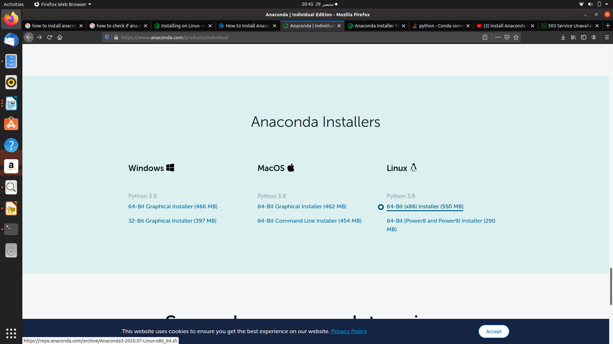
click on linux version and download it.


Click on help & training
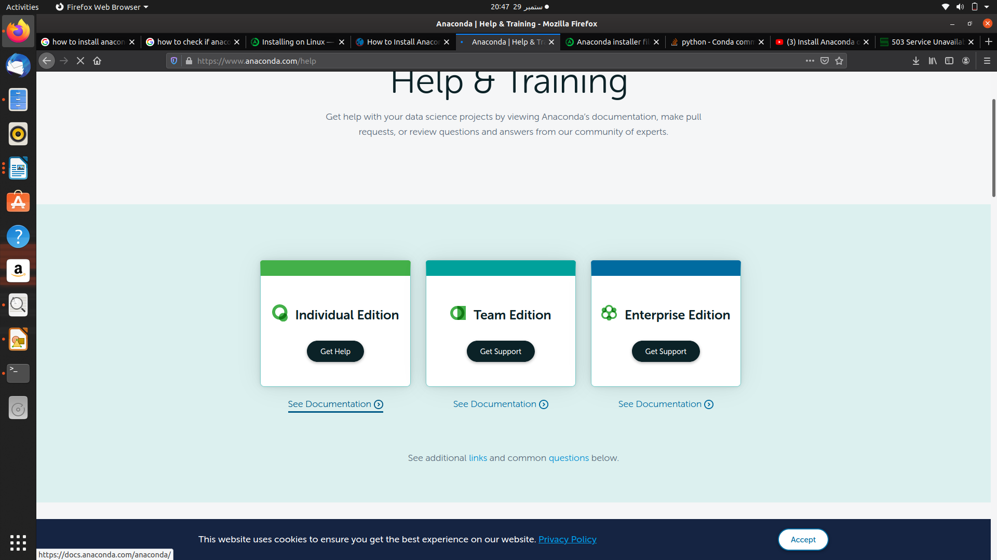
now click on see documentation.
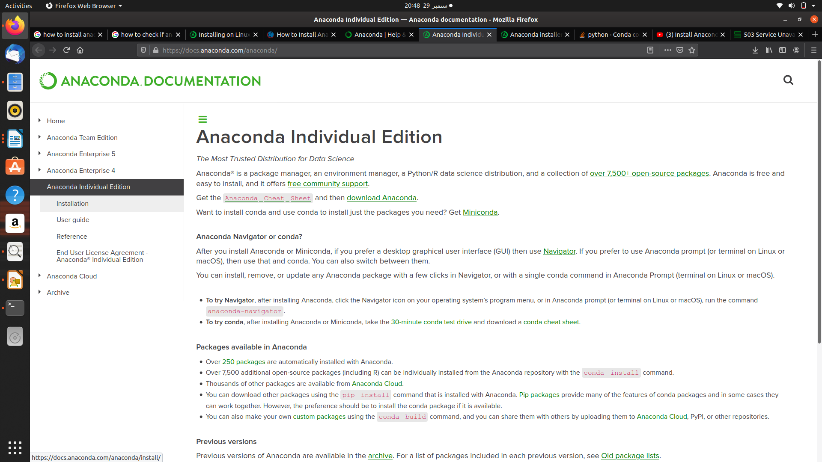
Now click on installation
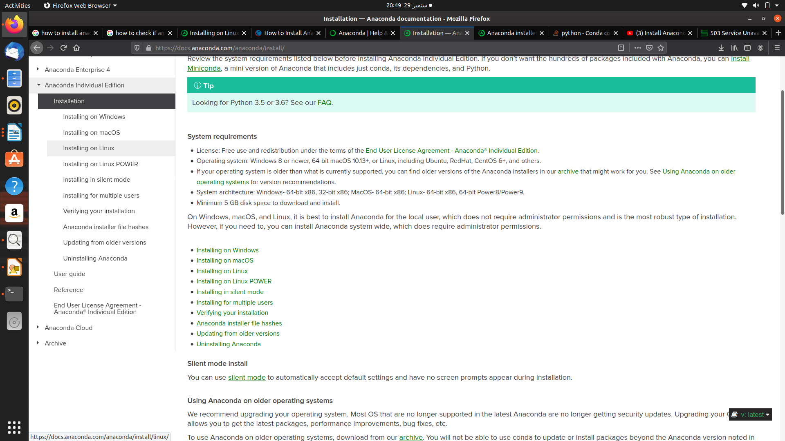
now click on installing on linux.
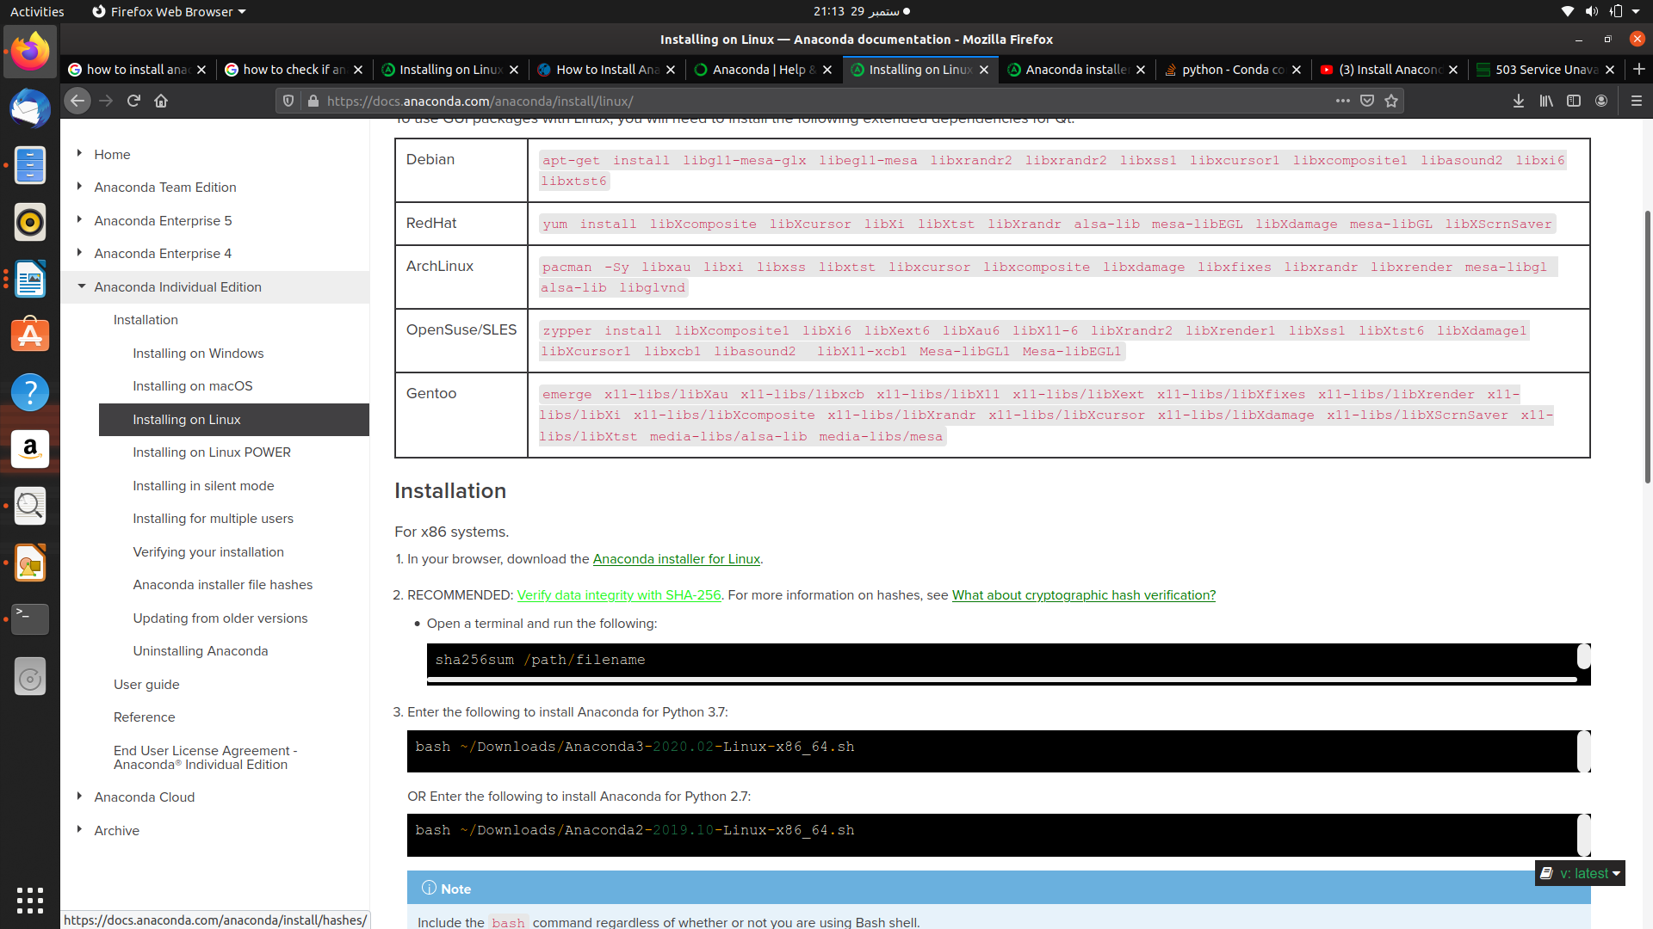
Click on verify the integrity with SHA
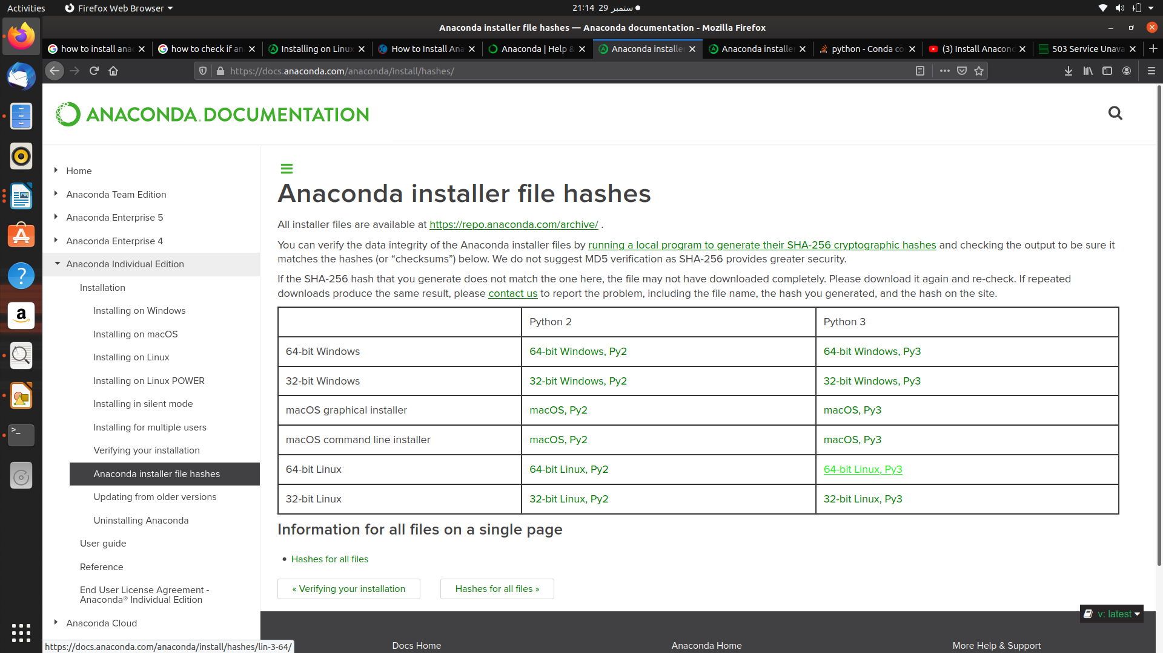
click on 64-bit linux Py3
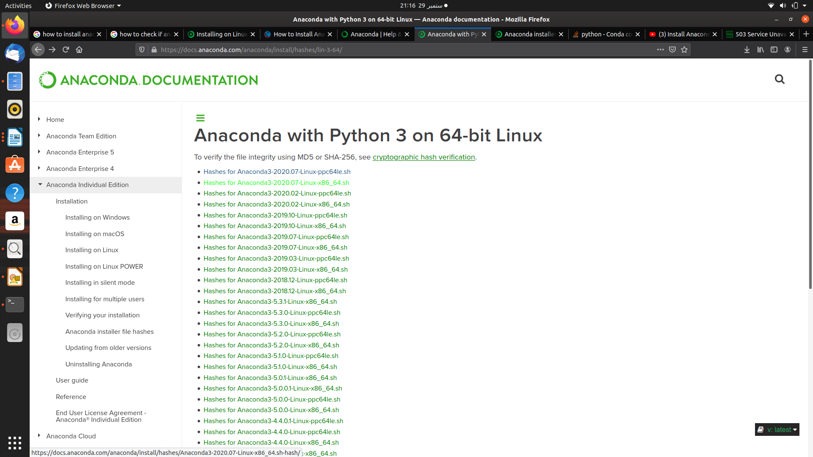
click on Hashes for Anaconda3-2020.07-linux-x86_64.sh
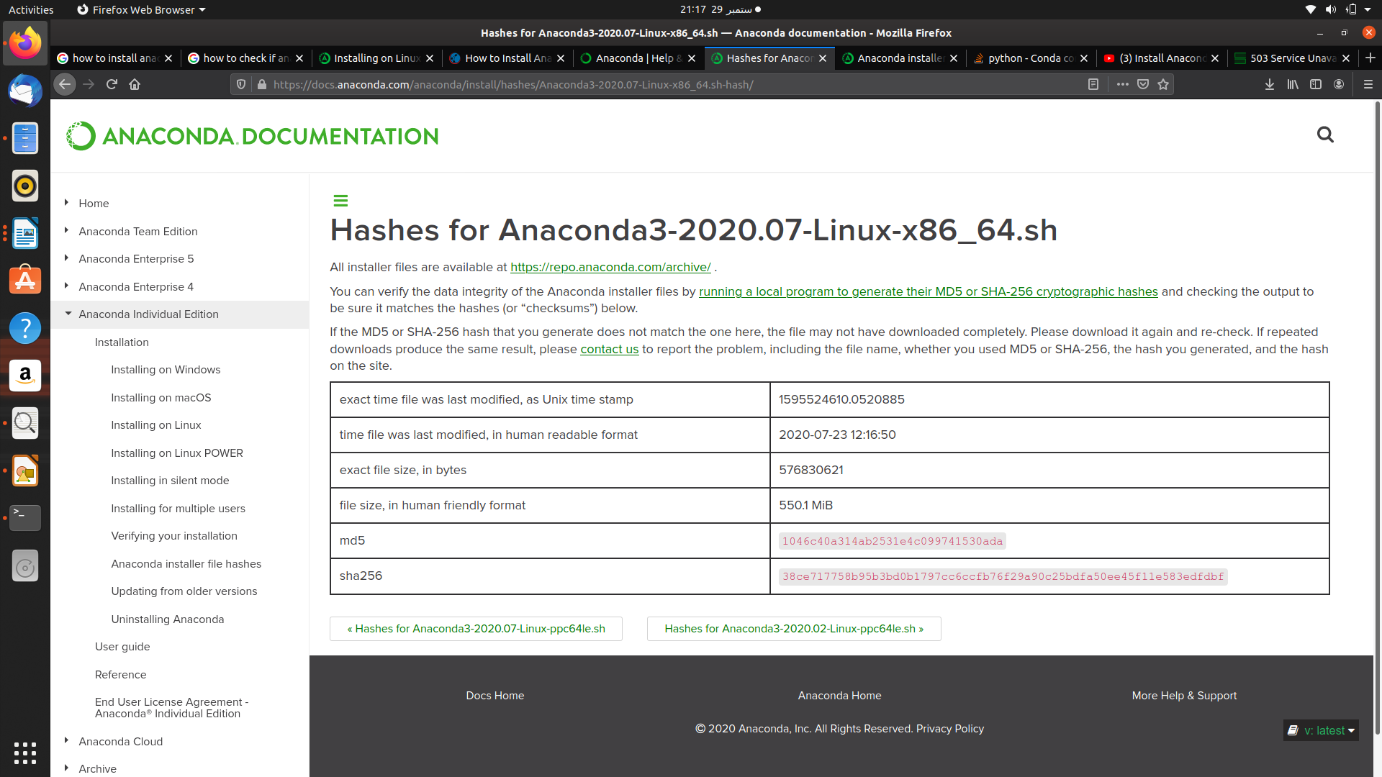
copy the sha256 value and paste it in textpad/notepad/libretext

Go to terminal and the commands
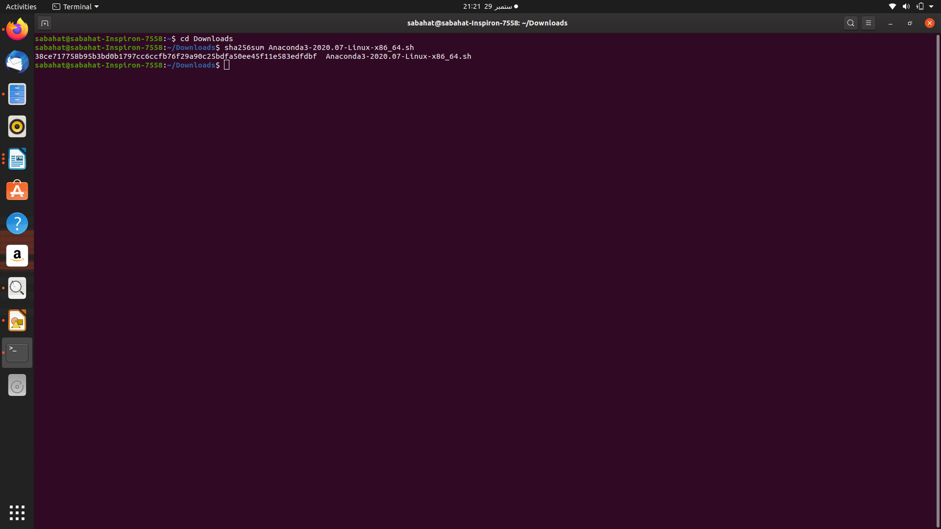
copy the sha value and paste it on the tet file and now match that both the values of sha are same or not?
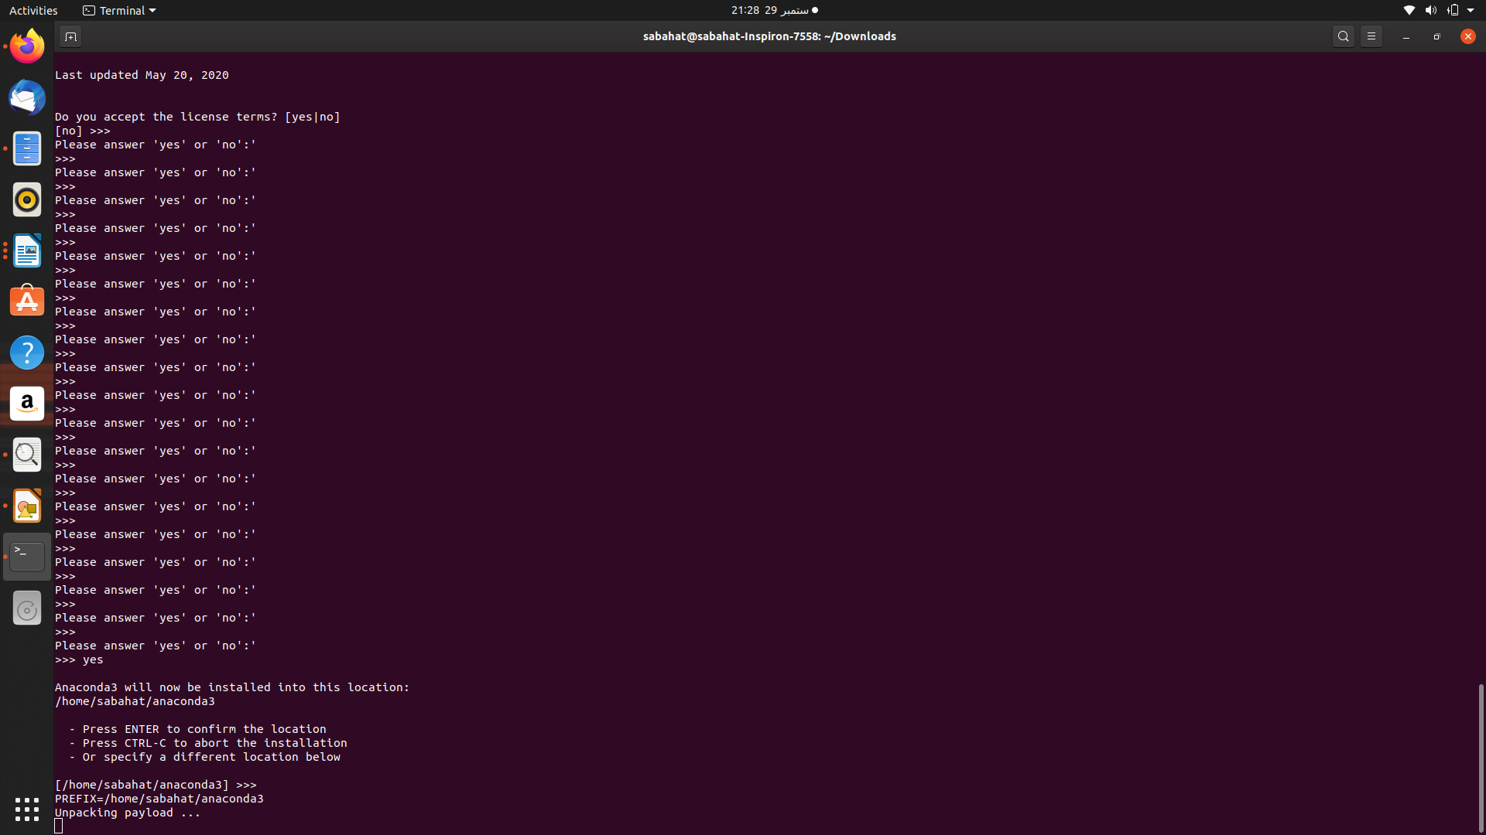
38ce717758b95b3bd0b1797cc6ccfb76f29a90c25bdfa50ee45f11e583edfdbf
38ce717758b95b3bd0b1797cc6ccfb76f29a90c25bdfa50ee45f11e583edfdbf
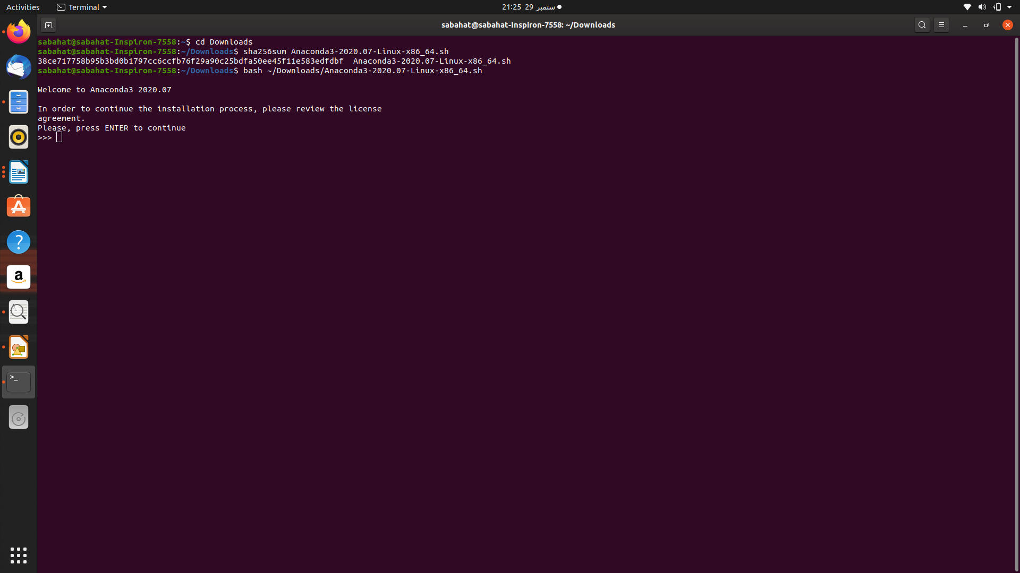
Run the command: bash ~/Downloads/Anaconda2-2020.07-Linux-x86_64.sh and press enter
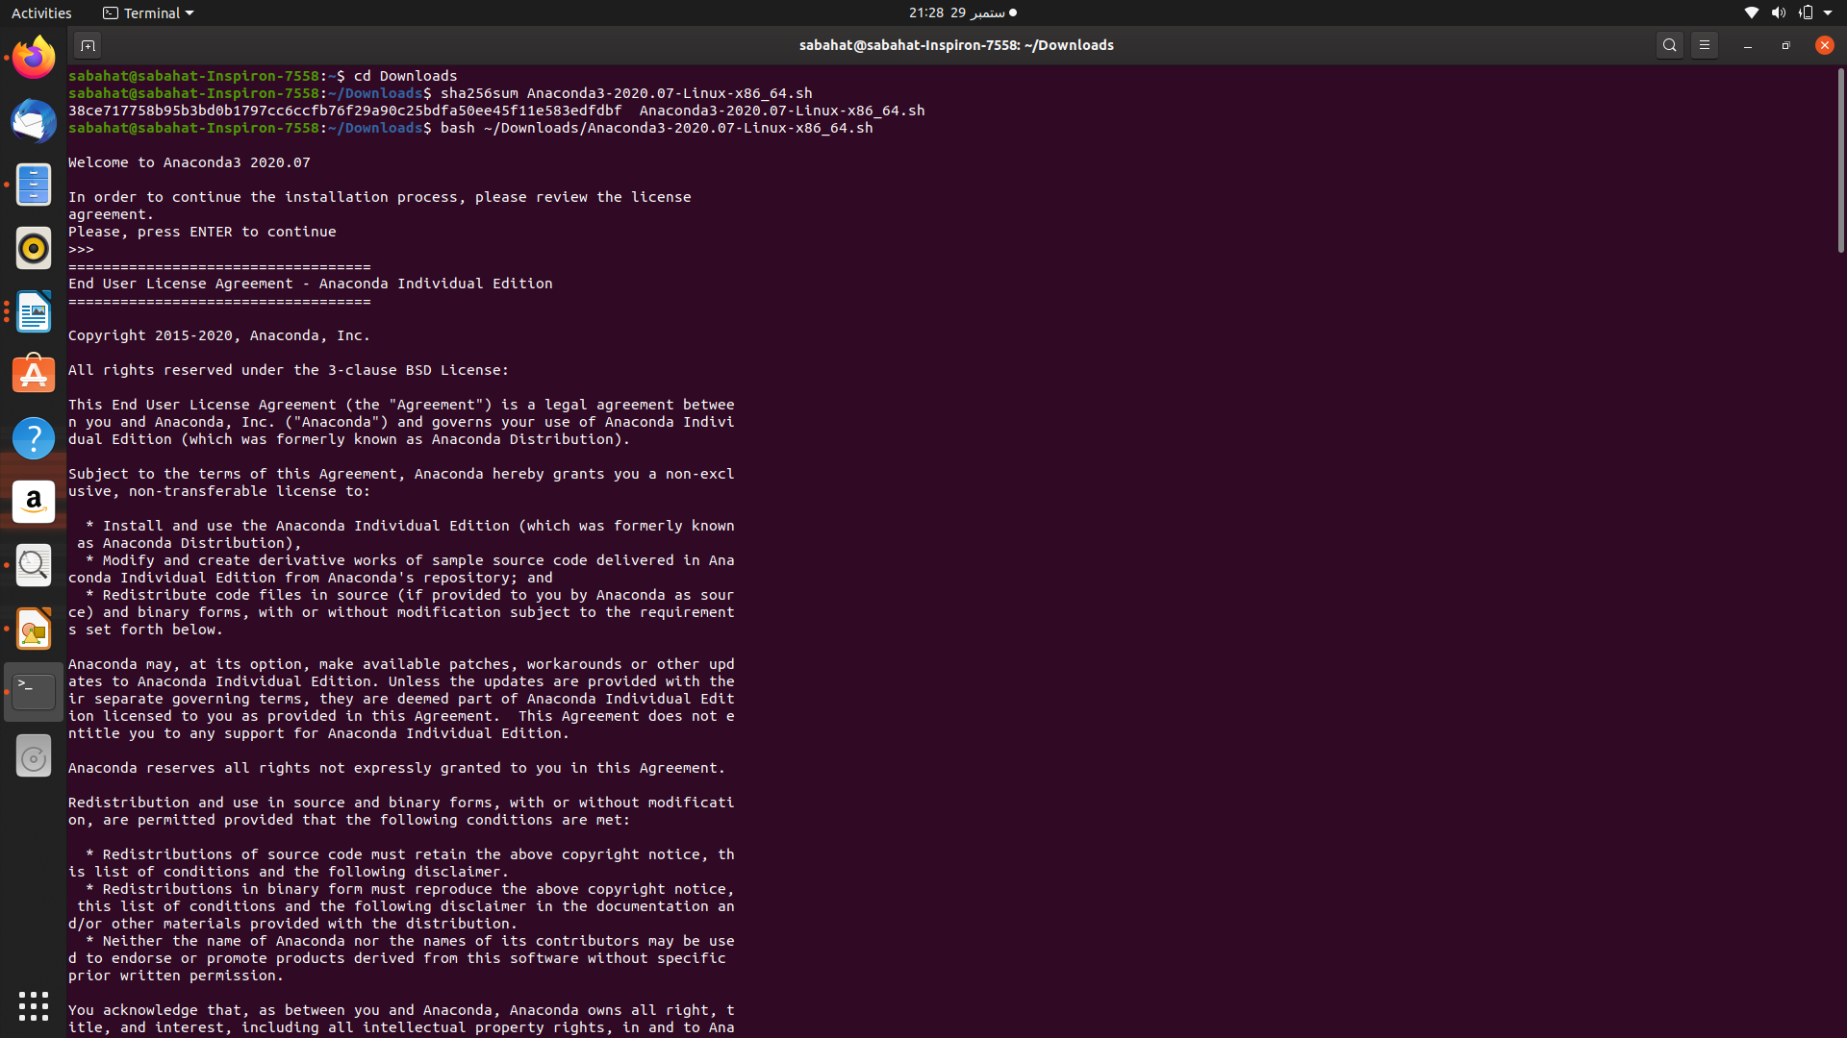
after that it will show some conditions just keep pressing enter until you get yes or no option
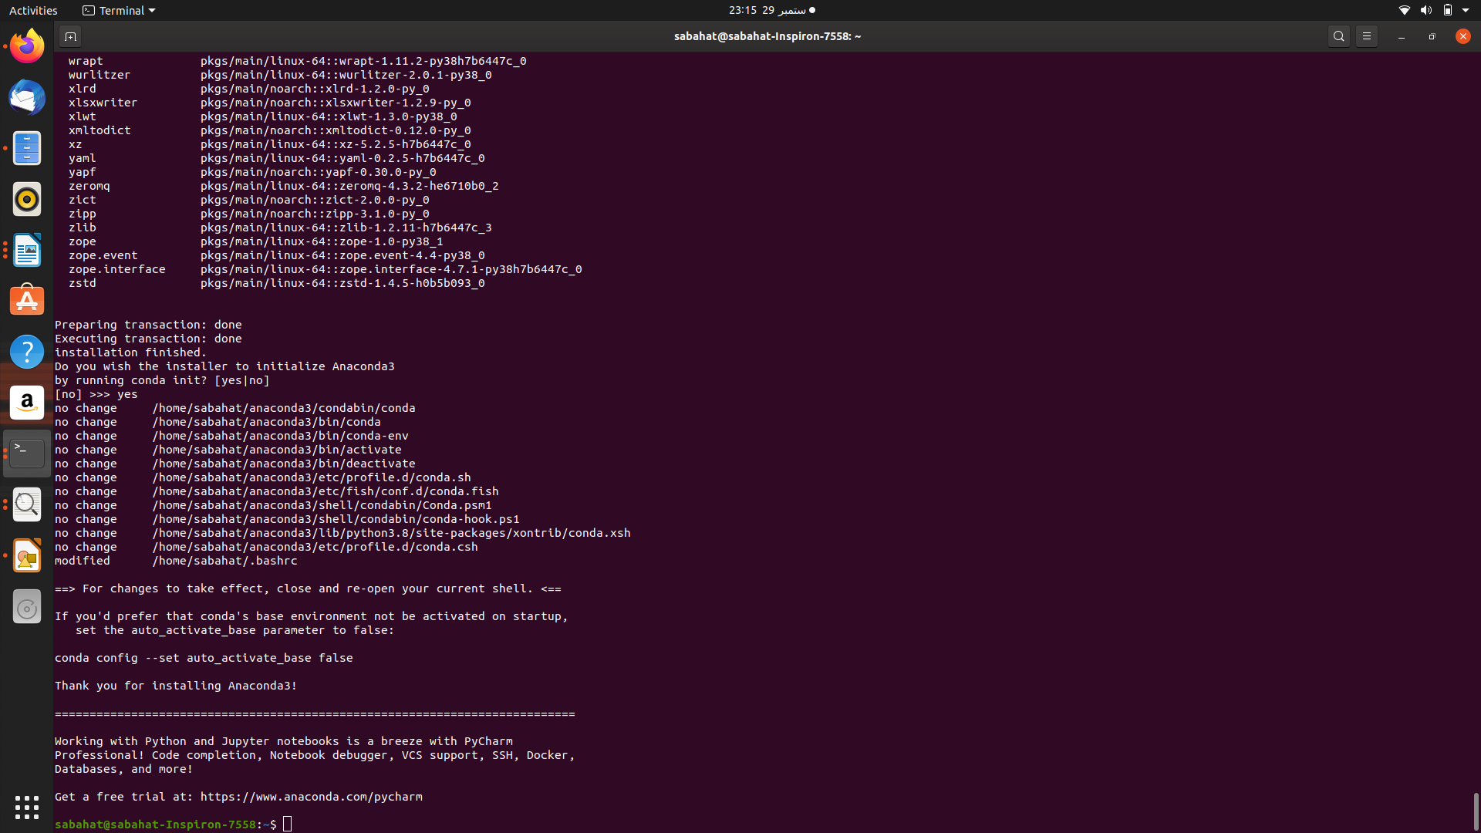

then excute
conda list
conda –version
jupyter-notebook
python --version

